Optional – needed to avoid null checks everytime
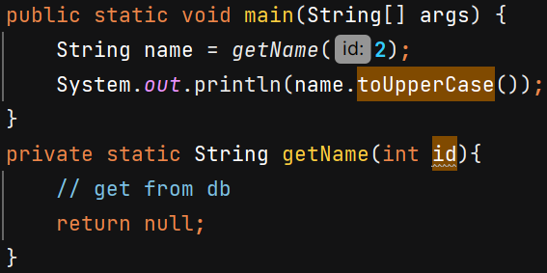 O/P NullPointerException
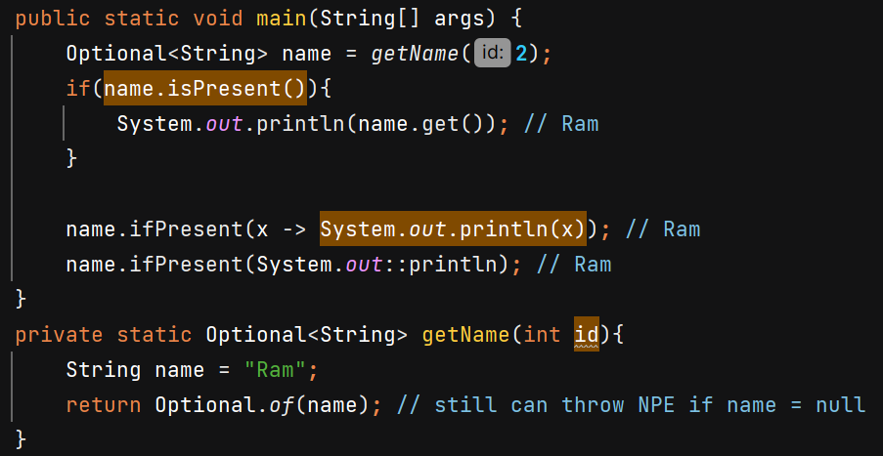
isPresent() checks if value is not null
ifPresent() takes a consumer and perform the task if value is not null.
Better to use - 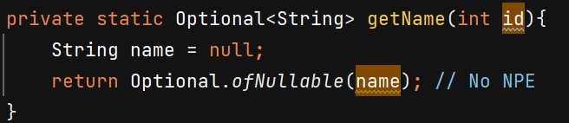
ofNullable Returns an Optional describing the given value, if non-null, otherwise returns an empty Optional.
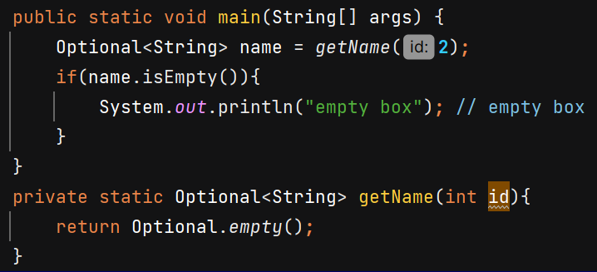
If value is null or empty we can get error so always check presence first –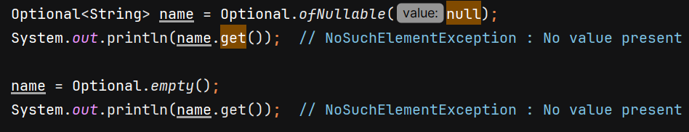
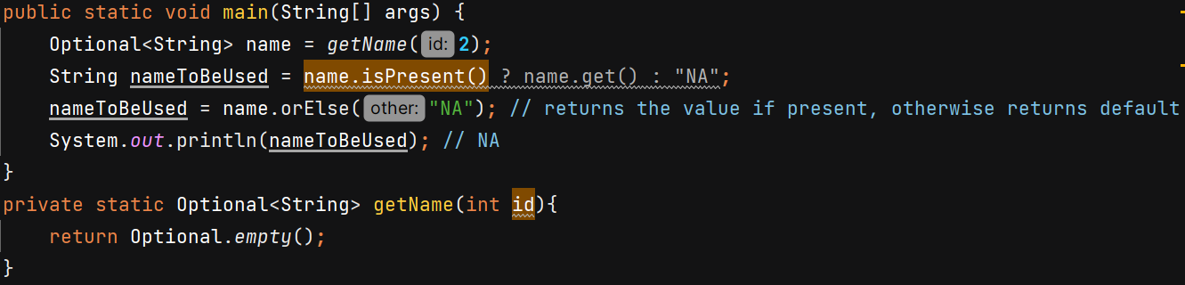
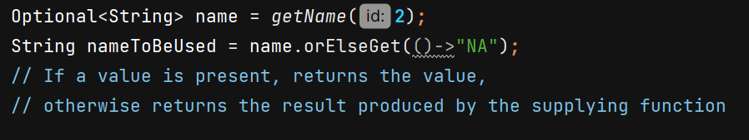
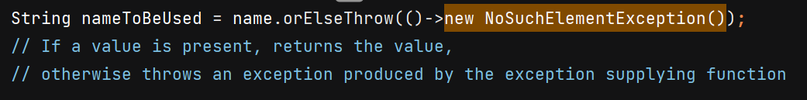
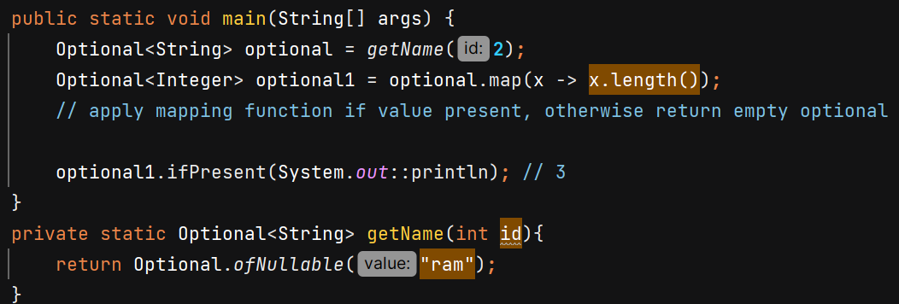
Method References 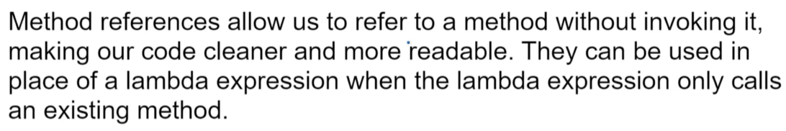
1. Reference to a Static method –
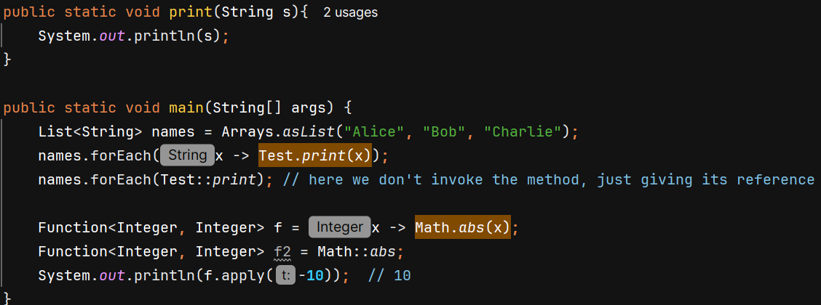

2. Reference to an Instance Method of a Specific Object -
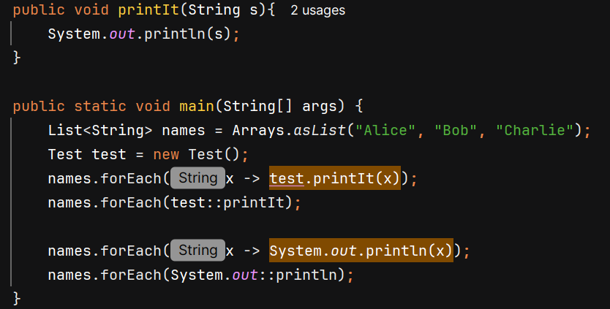

3. Reference to an Instance Method of a Class -
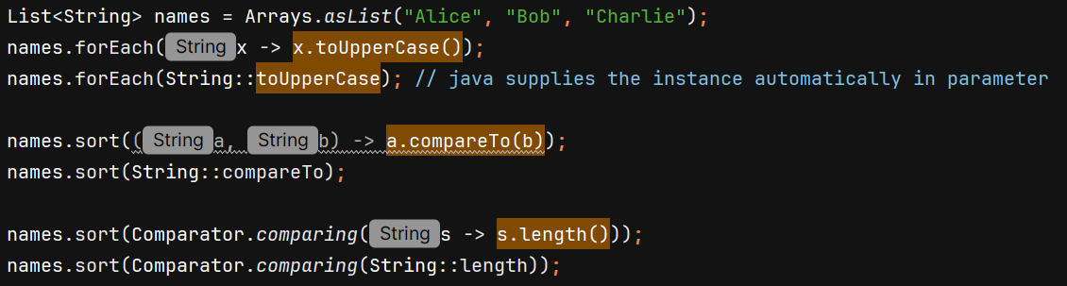

Constructor Reference
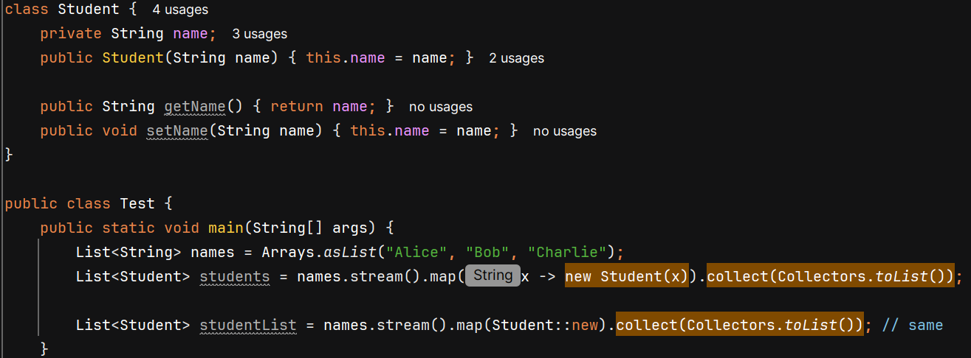
Streams
- Java 8 -> minimal code, functional programming (treating function as variable)
- new features -> lambda expression, Streams, Date & Time API
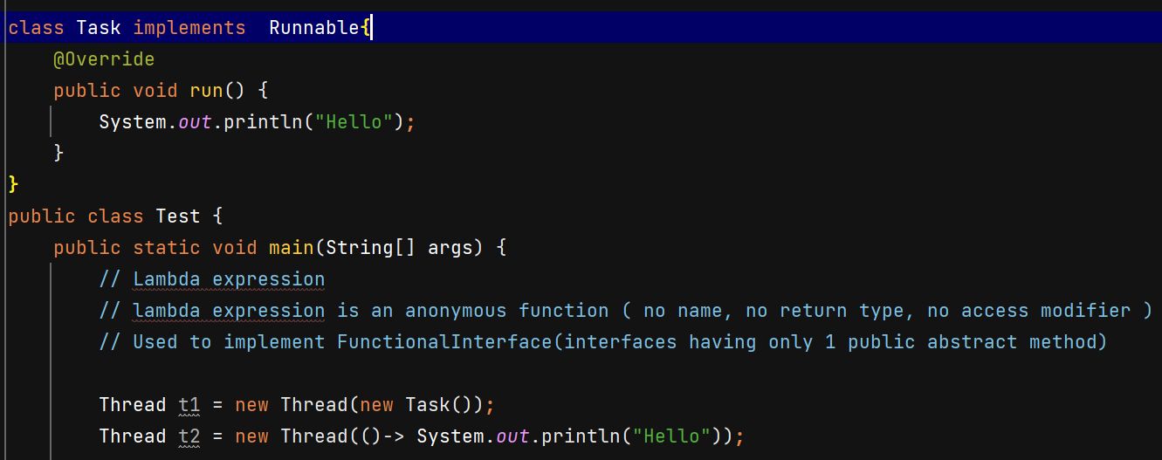
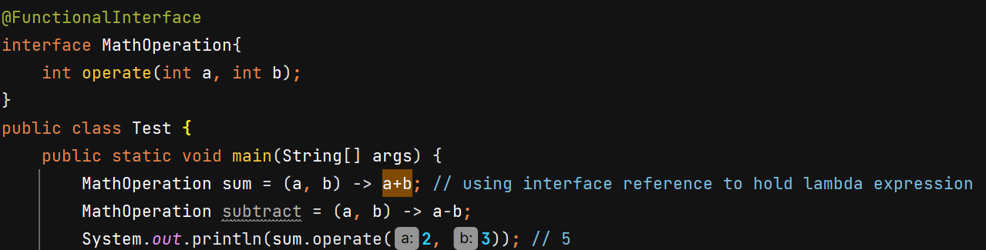
Predicate functional interface (boolean valued function)
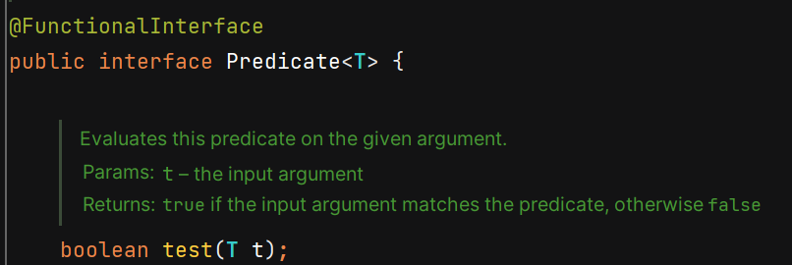
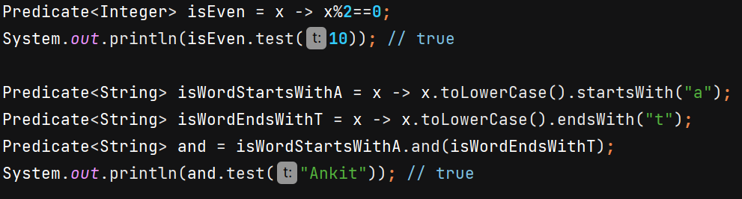we can add(), or(), negate() etc with Predicate

Function work for you
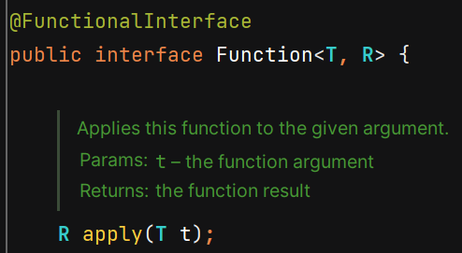
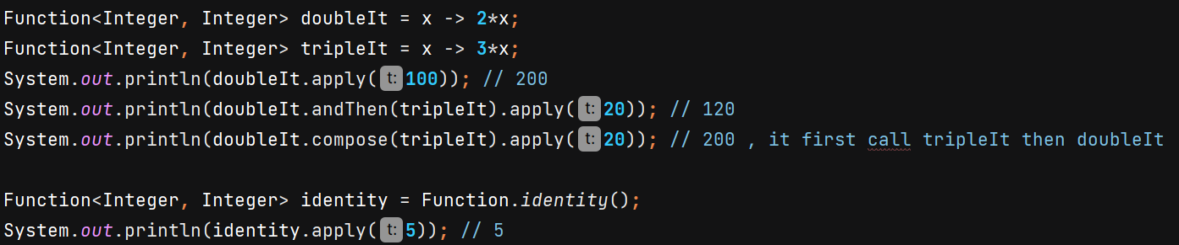

Consumer 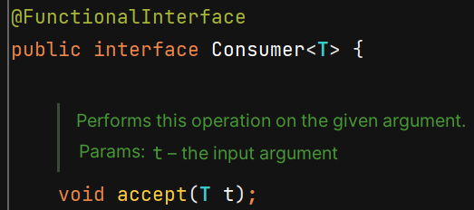
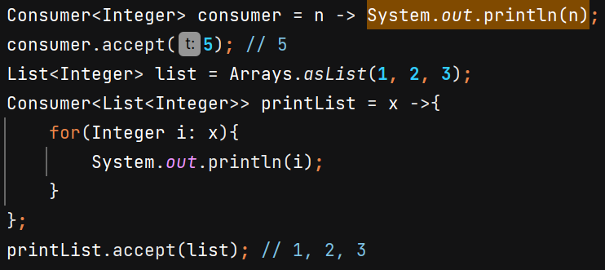 andThen() is available in it.

Supplier 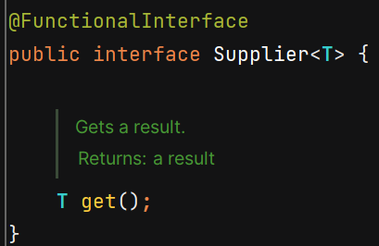

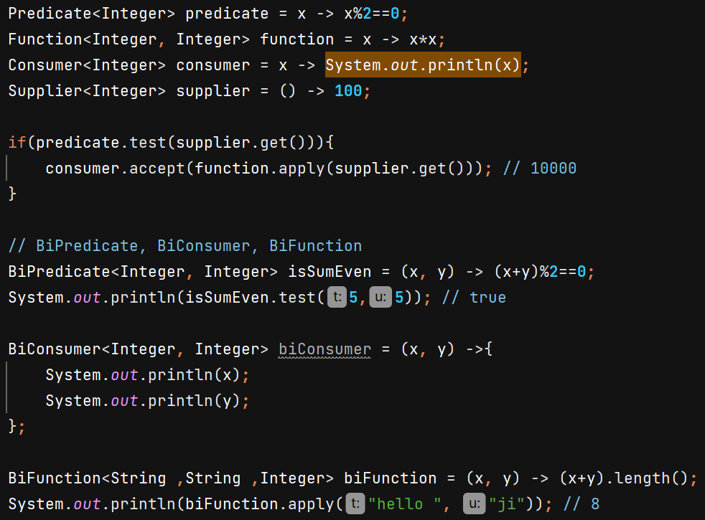

UnaryOperator 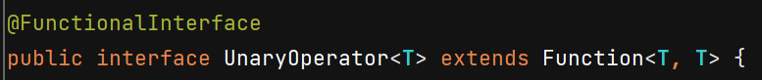
BinaryOperator 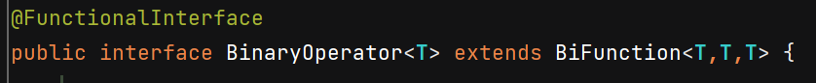
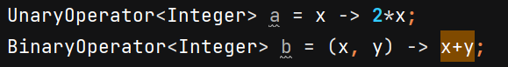

Method Reference use method without invoking in place of lambda expression
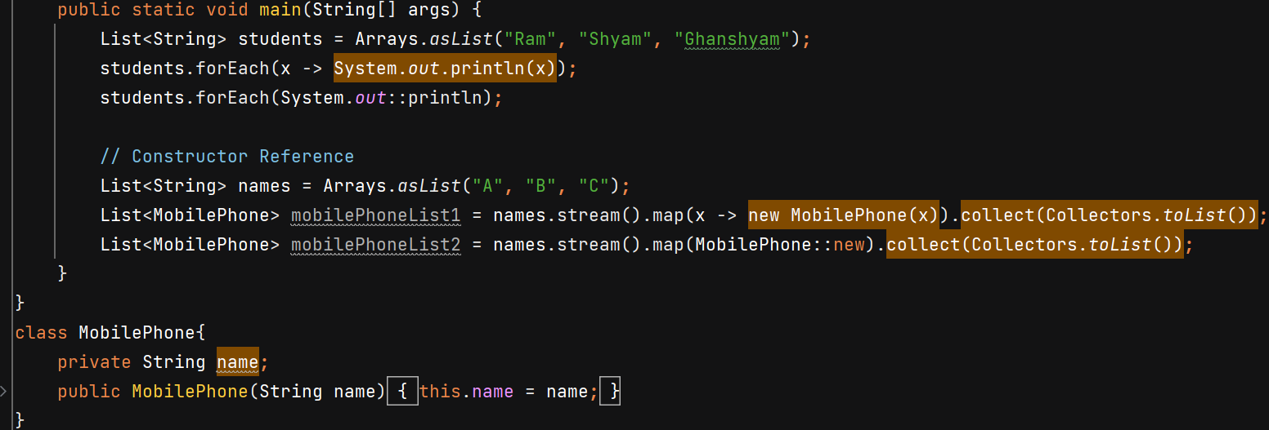

Streams
- process collections of data in a functional and declarative manner
- Simplify Data Processing
- Improve Readability and Maintainability
- Enable Easy Parallelism
- How to Use Streams?
Source, intermediate operations & terminal operation
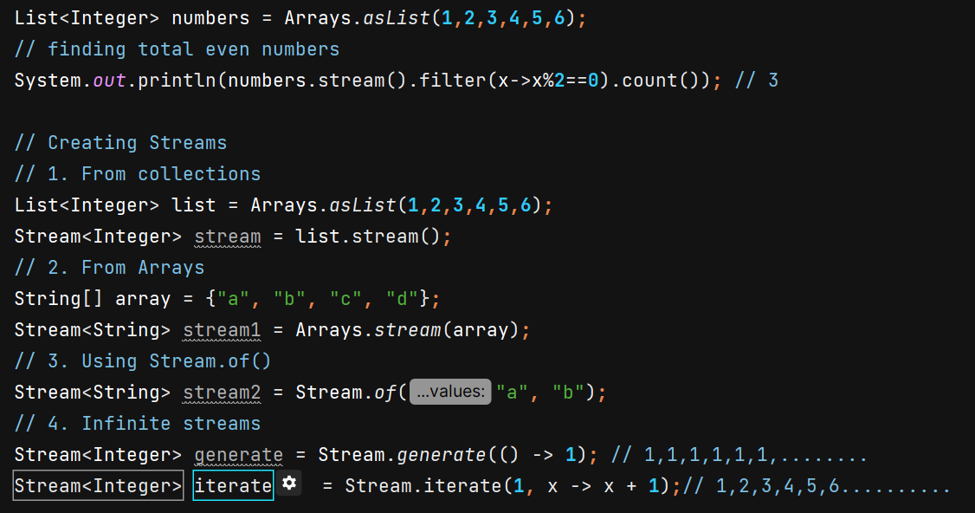

In Java, streams are immutable — once a stream is created, you cannot add elements to it.

Use of concat() and Stream.Builder –
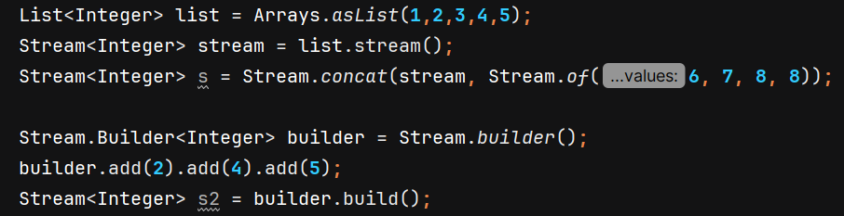

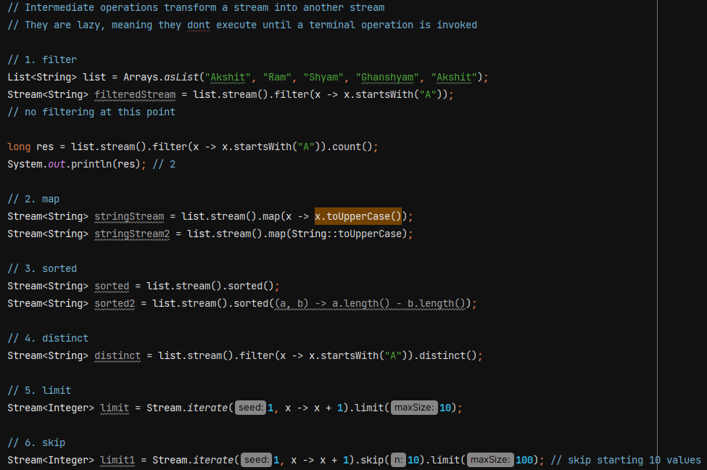
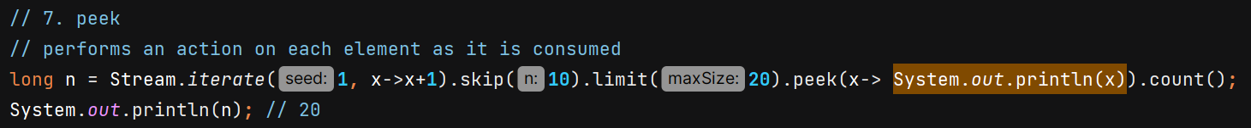

flatMap() is used when you have a stream of collections (or arrays), and you want to "flatten" them into a single stream of their individual elements.
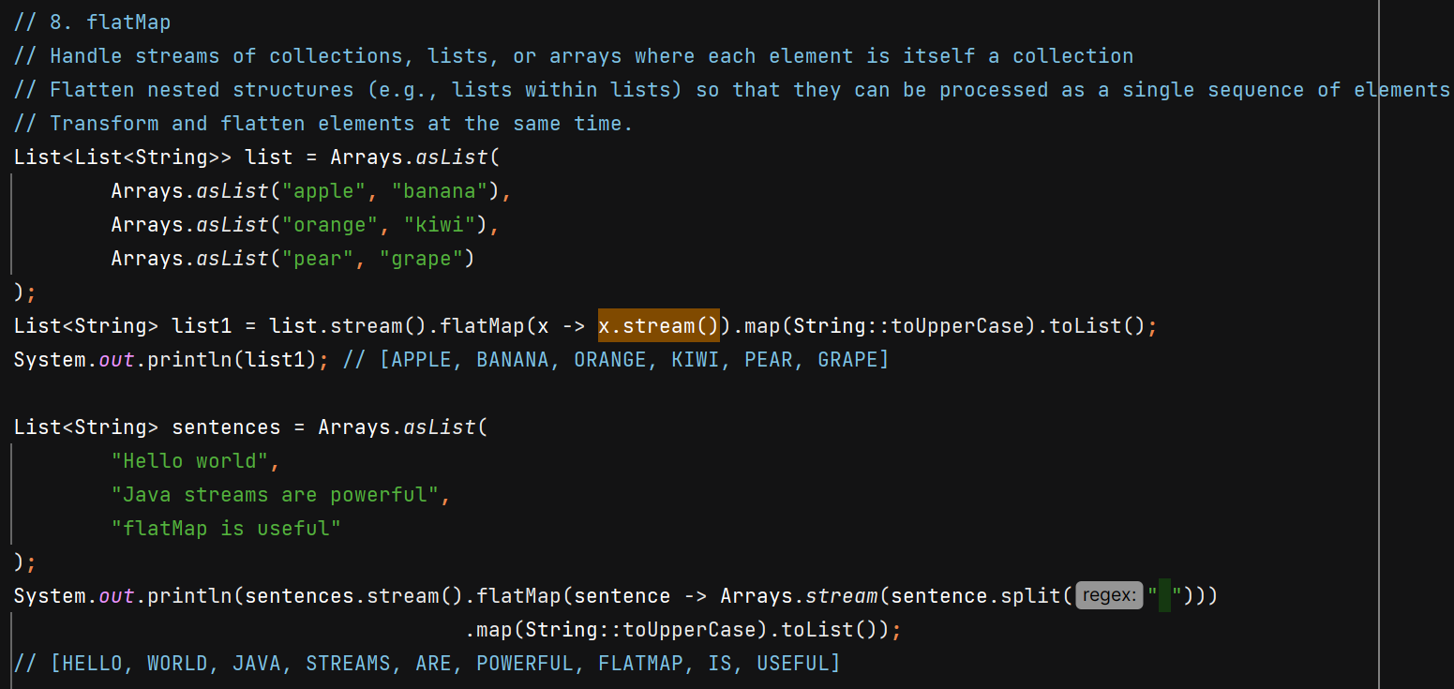
Terminal operators –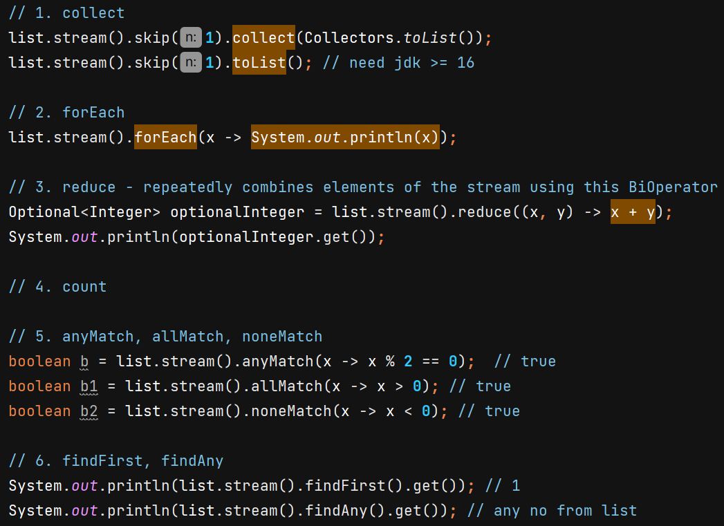
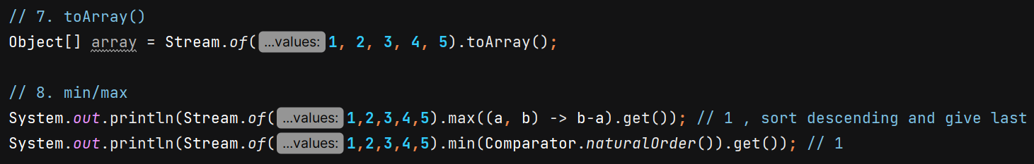
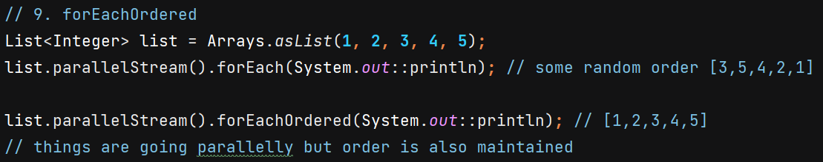
ParallelStream allows us to process elements of a stream in parallel, leveraging multiple CPU cores.

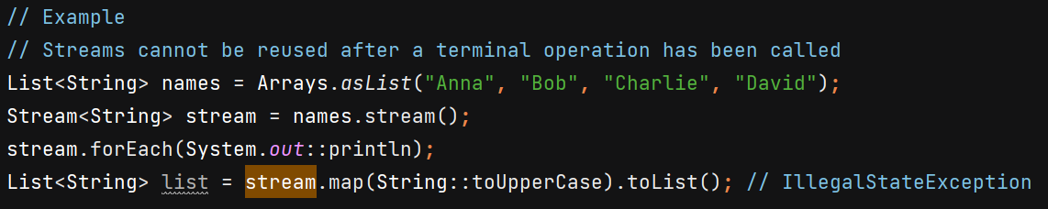

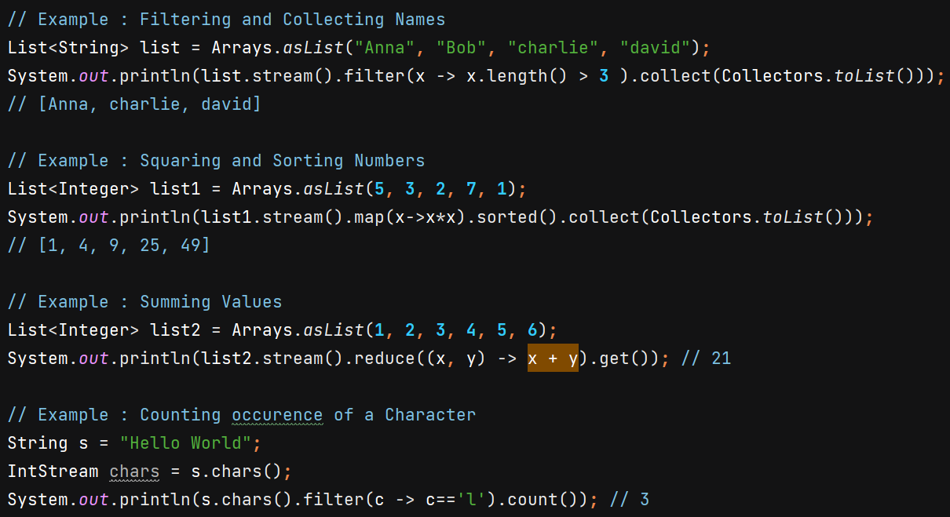
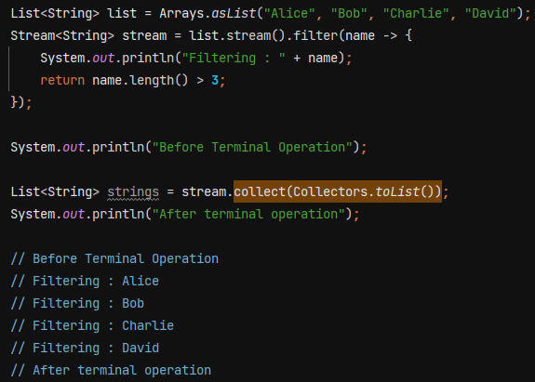
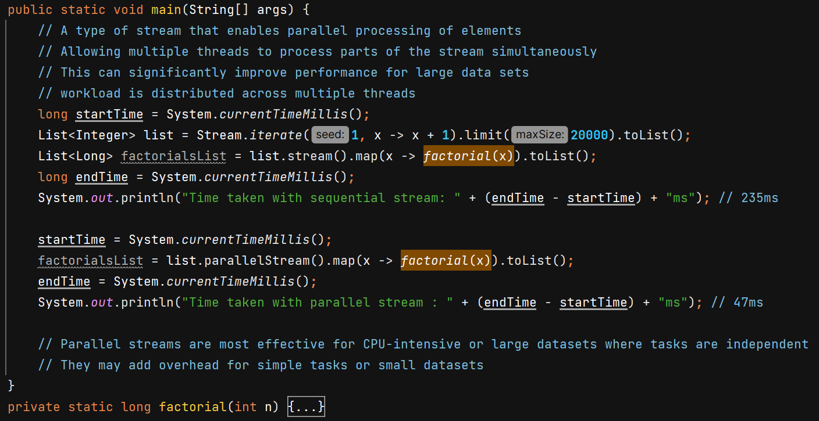
We can convert parallelStream to sequential –
parallelStream don’t work here -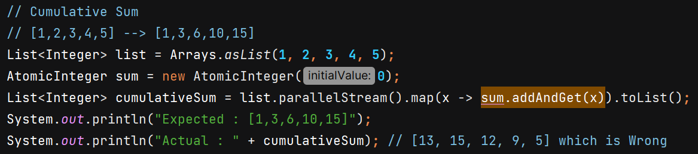

Collectors – It is a utility class which provides a set of method to create a common collectors
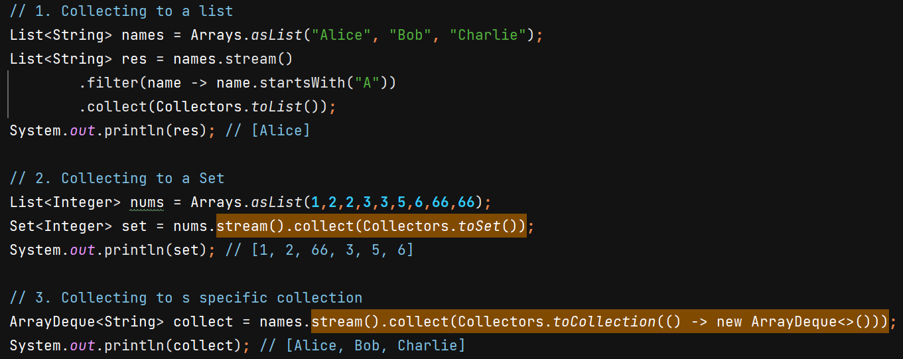
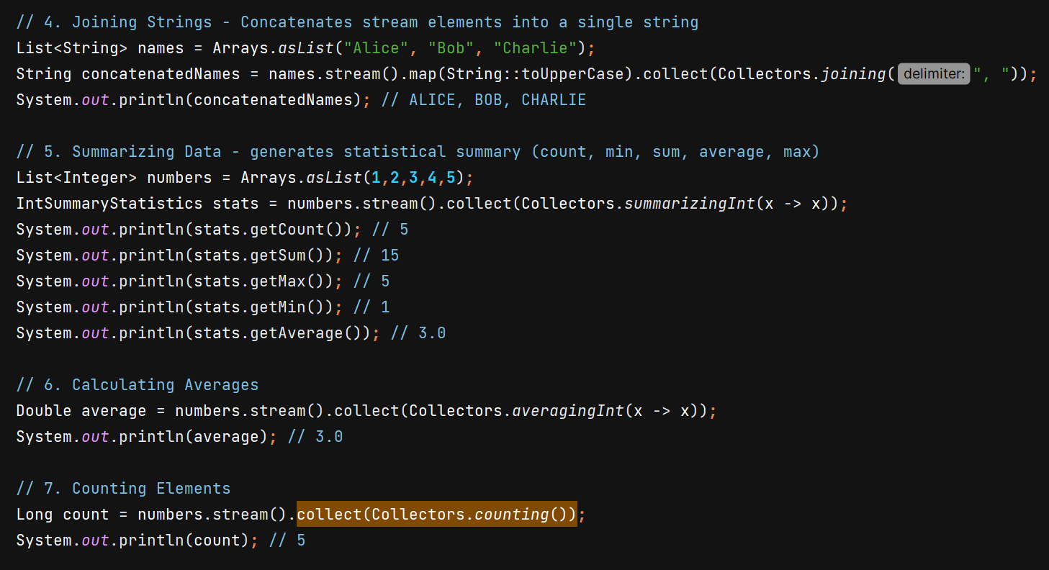

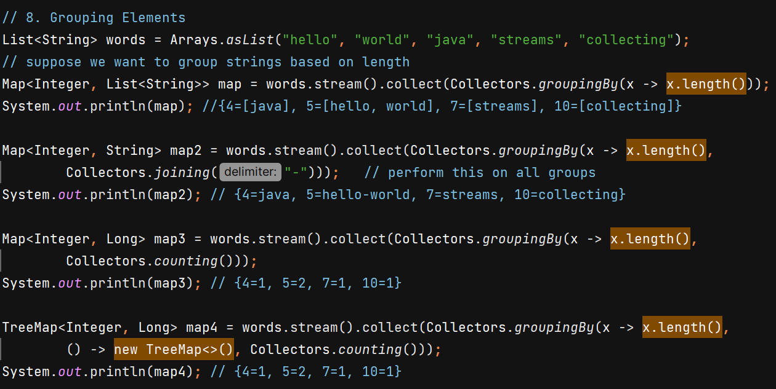
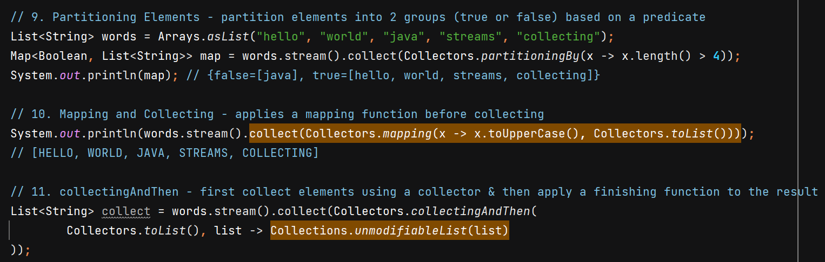
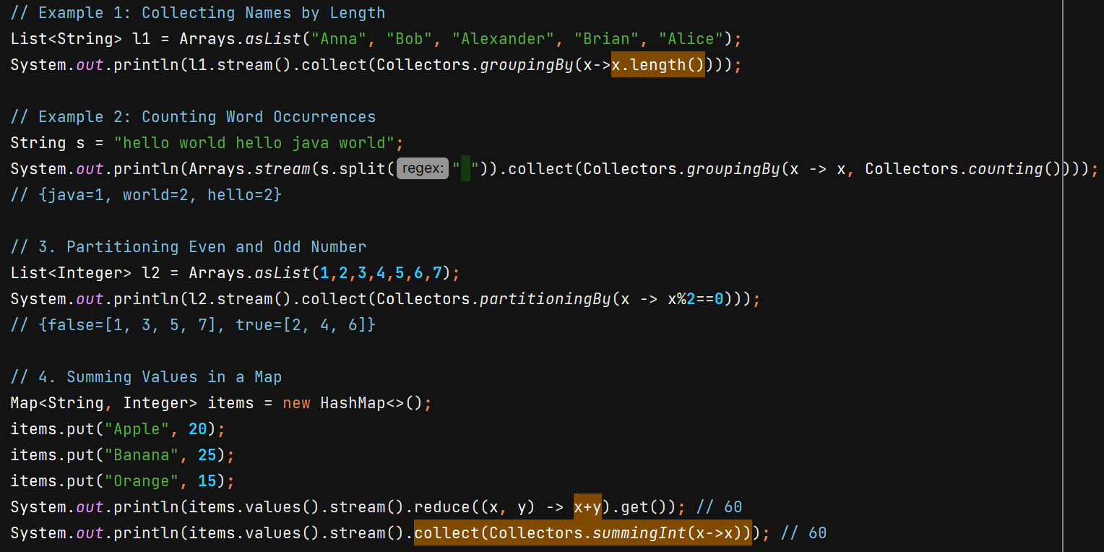
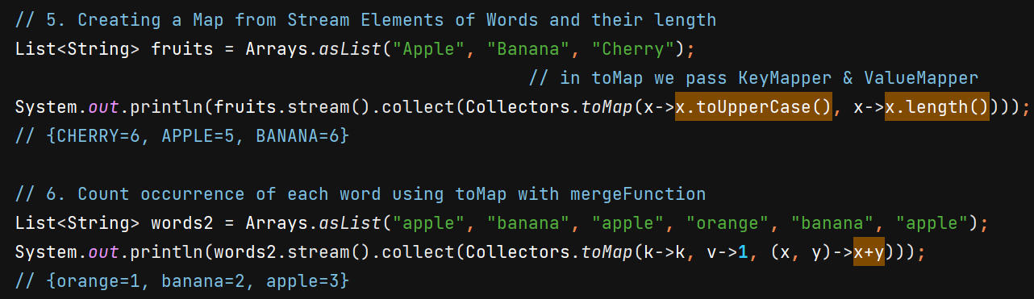

Primitive Streams
